General Introduction

Overview
This project is a turn-based, grid-based tactical strategy game inspired by classic tactical RPGs.
Players control a small squad of units on a tile map and take turns moving, attacking, and positioning units to defeat all enemies on the map.
The game is played entirely in the terminal, using keyboard input to select units, move them across the map, and engage in combat.

Core Gameplay Loop
A game progresses through repeated player turns and enemy turns until one side is completely defeated.

1. Player Turn
During the player turn, you may:
- Select player-controlled units
- Move each unit once per turn
- Choose weapons
- Attack enemy units within range
- End your turn when finished
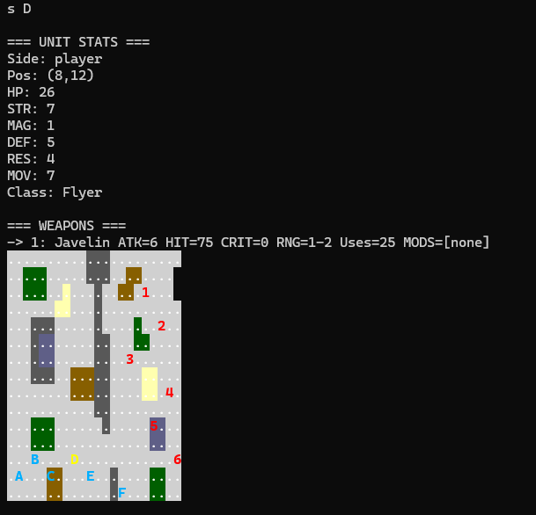
D is selected and thus marked yellow
Each player unit can:
- Move once
- Attack once
- Switch weapons freely before attacking
Once a unit has moved, it cannot be moved again until the next player turn.
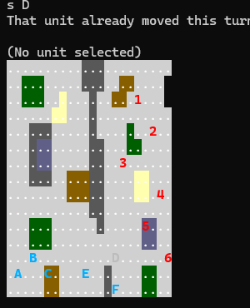
after being moved D is grey and cant be moved agian

2. Combat
Combat occurs when a unit attacks an enemy within its weapon’s range.
Before confirming an attack, the game displays a combat preview, showing:
- Expected damage
- Hit chance
- Critical hit chance
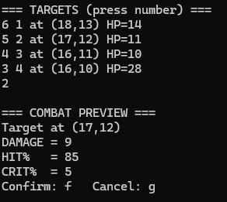
exmaple preview
Combat is resolved in this order:
- Attacker strikes
- If the defender survives and has a valid weapon in range, they may counterattack
All combat uses probability-based hit and critical calculations.
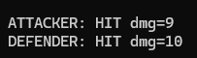
:example comabat result

3. Enemy Turn
After the player ends their turn:
- The enemy AI takes control
- Each enemy unit:
  - Moves toward the nearest player unit
  - Attempts to attack if possible
Enemy actions are automatic and follow simple tactical rules based on distance and weapon range.
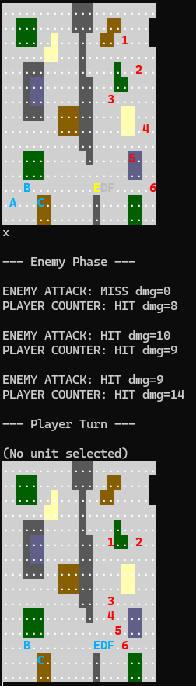
example enemy phase

4. Turn Reset
At the start of the next player turn:
- All player units have their movement reset
- The player may act with all surviving units again

5. Victory and Defeat Conditions
- Victory: All enemy units are defeated
- Defeat: All player units are defeated
The game immediately ends when one side has no remaining living units.

6. Units and Terrain
- Units occupy a single tile on the map
- Terrain affects:
  - Movement cost
  - Combat effectiveness
- Some unit classes interact differently with terrain (e.g., flying units)
Detailed explanations of:
- Unit stats
- Weapon mechanics
- Terrain effects
are documented in separate files.

7. Map-Based Gameplay
Each battle takes place on a map loaded from a text file.
The map defines:
- The terrain layout
- Initial unit placement
- Unit classes and equipment
Map file structure and syntax are documented separately.

8. Controls and Interface
The game is controlled entirely via keyboard input in the terminal.
A full list of controls and command descriptions is provided in a dedicated controls document.

